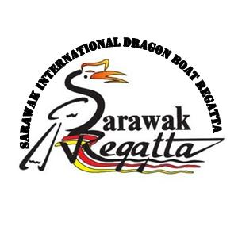
©2017.

SARAWAK INTERNATIONAL DRAGON BOAT REGATTA 2017
PROVISIONAL ENTRY FORM

( Please submit on or before 1st September 2017 )

Name Of Association/Club/Team
Contact Person
Phone Number | Mobile | Office | Residence
Fax Number
E-Mail Address

Mailing Address

 | RACE EVENT | 12 Crews | 20 Crews | 400 metres
1. | International Premier Open
2. | International Premier Mix
3. | International Premier Ladies
4 | International Premier Masters (age 40+)
5 | Sarawak Closed Race (For Sarawakians Only)

In the following table, indicate your number of participants

NO | DELEGATION | GENDER
 |  | MALE | FEMALE
1. | Team Manager
2. | Coach / Team Captain
3. | Steerer
4. | Drummer
5. | Paddlers
6. | Reserves
TOTAL

Signature :________________ Name of Team Manager :__________________________

Date :________________
©2017. Copyrights by HARLIE VENTURE (MALAYSIA)
http://harlieventure.weebly.com

