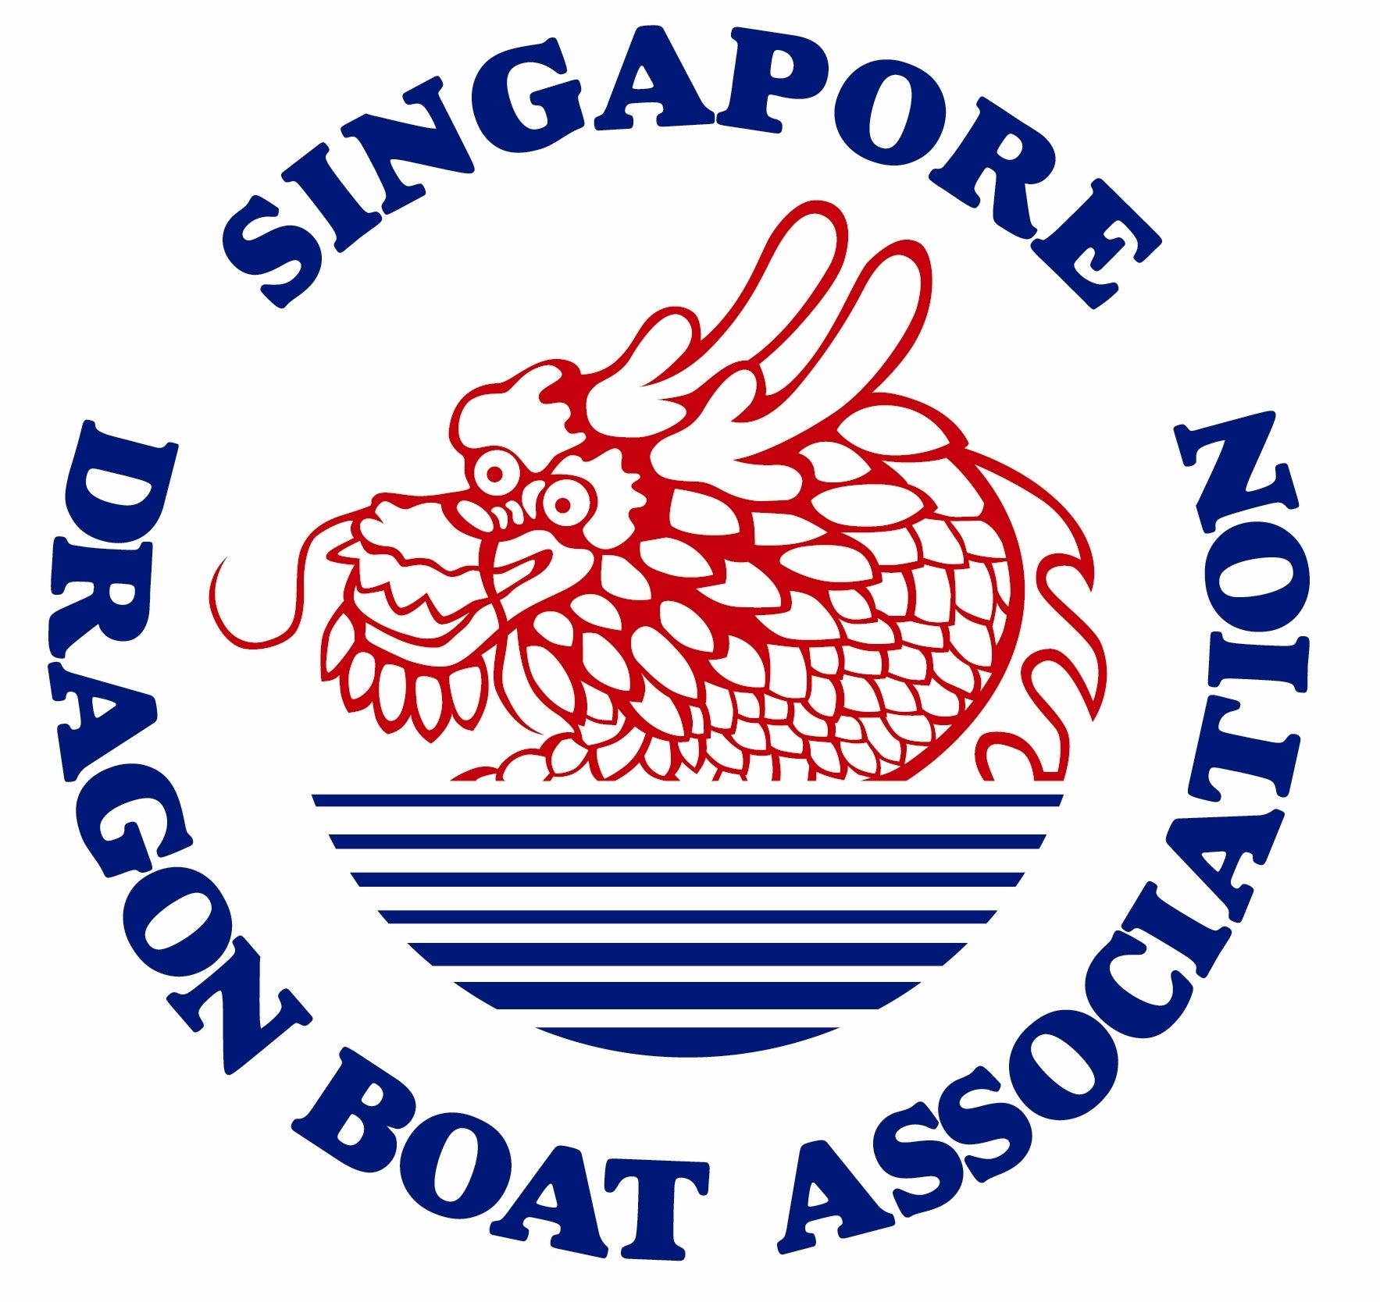****

**F2b: REGISTRATION OF INTEREST -** for overseas teams

Name of Team:

Country:

Name of Team Manager:

Email of contact person: Mobile No:

wechat or whatsApp ID: (if you wish to be contacted by Wechat or Whatsapp)

We would like to participate in the following categories for the DBSMR 2018:

|  |  |  |  |  |
| --- | --- | --- | --- | --- |
| **DATE** | **CATEGORY** | **DISTANCE** | Please tick / mark accordingly: | **Remark** |
| **26 MAY 2018**  **(Saturday)** | Dragon Boat 12-crew (DB12) DBS Premier Mixed | **500m** |  |  |
| Dragon Boat 12-crew (DB12) DBS Corporate Mixed | **500m** |  |  |
| Dragon Boat 12-crew (DB12) Community Novelty Race  - Active Agers Community Open | **200m** |  |  |
| Dragon Boat 12-crew (DB12) Community Novelty Race  - Adaptive Community Open | **200m** |  |  |
| Dragon Boat 12-crew (DB12) Community Novelty Race  - Survivor Series Open | **200m** |  |  |
| **27 MAY 2018**  **(Sunday)** | Dragon Boat 22-crew (DB22) DBS Premier Open | **500m** |  |  |
| Dragon Boat 12-crew (DB12) DBS Premier Women | **500m** |  |  |
| Dragon Boat 12-crew (DB12) DBS Corporate Open | **500m** |  |  |
| Dragon Boat 12-crew (DB12) DBS Corporate Women | **500m** |  |  |
| **2 June 2018**  **(Saturday)** | Dragon Boat 12-crew (DB12) DBS Premier Mixed | **200m** |  |  |
| Dragon Boat 12-crew (DB12) DBS Corporate Mixed | **200m** |  |  |
| Dragon Boat 12-crew (DB12) DBS Prime Warriors Mixed | **200m** |  |  |
| Dragon Boat 12-crew (DB12) DBS Millennium Mixed | **200m** |  |  |
| **3 June 2018**  **(Sunday)** | Dragon Boat 22-crew (DB22) DBS Premier Open | **200m** |  |  |
| Dragon Boat 12-crew (DB12) DBS Premier Women | **200m** |  |  |
| Dragon Boat 12-crew (DB12) DBS Corporate Open | **200m** |  |  |
| Dragon Boat 12-crew (DB12) DBS Corporate Women | **200m** |  |  |

Please email this form to [race@sdba.org.sg](mailto:race@sdba.org.sg) by 29 April 2018. Thank you.