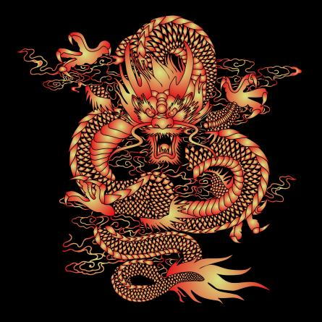

**世界華人運動會世界華人龍舟聯盟委員會**

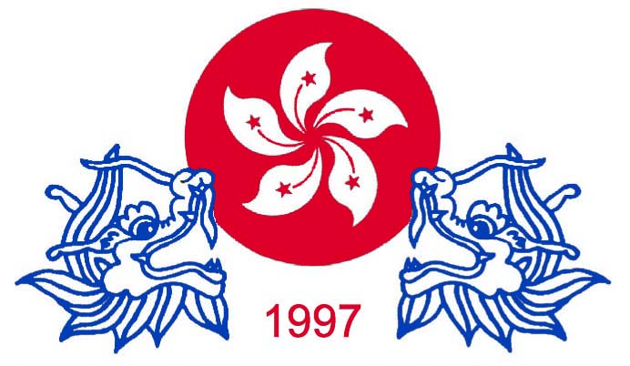

**中國香港特別行政區龍舟聯會**

China Hong Kong Special Administrative Region Dragon Boat Federation

香港新界深井碧堤半島第八座38樓C室 / Tel : 68213948 *Affiliate Festival*

中國通訊地址 : 北京市西冀黃城根北街21號東樓 電話 : 86 – 10 – 52606845

廣州市越秀區解放南路123號金匯大廈26樓 86-13610277265

Invitation 4 February , 2018 .

**2018 China 2 City International Dragon Boat Festival**

Dear All Dragon Boat Federation, Association, Club, Teams President, Teams Manager

On behalf of CHKSARDBF and CHINA Jiangsu Nantong City , Guangzhou City International Dragon

Boat Festival Organizing Committee . I am taking this opportunity of inform you that the China Hong Kong

SAR Dragon Boat Federation is coordinating the captioned event.

We have just finalized preparation for the said festival and invitation with events particulars

and expected to be sent out early month .

I shall be most grateful if you could assist us in circulating this information to your fellow

members and dispatch the information in your website and also publish it in your forth coming new

letter and update .

We feel grateful for your never ending kind support in our dragon boat festival and we love

to recommend you and your team to The 2018 China 2 City (15–24 June, 2018) International

Dragon Boat Festival .

Do feel free to contact me should you need any further information or assistance. Please help

us to forward To other Dragon boat Association and Club.

Details of The 2018 China 2 City International Dragon Boat Festival are as follow:

1. Nantong City from 15 to 19 June , 2018. Races in 500M / 7 KM International Man open ,

Women open . Jiangsu Nantong City 23 crew Boat . (have money prize award )

2. Guangzhou City from 20 to 24 June 2018. Races 600 M 22 crew Boat International Man open ,

Women open .

Hosted each team accommodation , meal and local transport for 28 people ( 20 paddlers ,

1 drummer ,1 steersmen , 1 gongmen , 3 reserve and 2 official ) .

The invitation teams are requested to flight to **Shanghai Pudong** Airport on 15 June 2018 where

our Liaison Officer and vehicles will meet your teams .

**Request :**

1. Arrival on 15 June , 2018 **Shanghai Pudong airport** where arranged to meet your teams. And

departure on 24 June 2018 from **Guangzhou airport** flight information for us . Request Arrival

and Departure flight details.

1. One passport size photo with name written on the back and passport copy for buy train tickets

in CHINA .

3. Request your teams insurance Copy .

4. Prepare a 10 minutes cultural show for presentation in celebration dinner (optional)

Dress in informal but dress smartly ( preferably in team uniform ) .

5. Teams history , list , photo before 15 April, 2018 . By post and e-mail send to Andrew Chan

( Flat C , 38/F, Tower 8 , BELLAGIO , Sham Tseng, N.T. Hong Kong )

6. All invitation teams please confirm before 15 April, 2018.

7. We request all oversea teams concentrate arrival at **Shanghai Pudong** airport on 15 June , 2018.

**Contact and Inquiry**:

Mr. Andrew CHAN. Flat C , 38/F , Tower 8 , BELLAGIO , Sham Tseng , N.T. Hong Kong .

e-mail [**chksardbf97@gmail.com**](mailto:chksardbf97@gmail.com)

Tel : (HK) +852 – 68213948 / +86 - 13610277265

中國秘書處 : 廣州市越秀區解放南路123號26樓

(China) + 86 – 13610277265

Your great assistance and support is truly appreciated.

Best regards,

Andrew CHAN 陳鏡清 主席

Chairman of The World Dragon Boat League Organizing Committee

of the Universal Chinese Sports Association

Chairman of China Hong Kong Special Administrative Region Dragon Boat Federation

Vice Director of China City International Dragon Boat Organizing Committee